# DNS (Domain Name Server) and Web Server Configuration

## Domain Name Server

A DNS server is a type of name server that manages, maintains and processes Internet domain names and their associated records. In other words, a DNS server is the primary component that implements the DNS (Domain Name System) protocol and provisions domain name resolution services to Web hosts and clients on an IP-based network.

## Web Server

A web server is a computer that runs websites. It's a computer program that distributes web pages as they are requisitioned. The basic objective of the web server is to store, process and deliver web pages to the users. This intercommunication is done using Hypertext Transfer Protocol (HTTP). These web pages are mostly static content that includes HTML documents, images, style sheets, test etc. Apart from HTTP, a web server also supports SMTP (Simple Mail transfer Protocol) and FTP (File Transfer Protocol) protocol for emailing and for file transfer and storage.

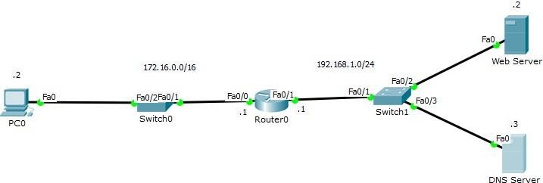

Figure 1

**Refer to figure 1,**

Task 1, IP on Router Router>enable Router#configure terminal

Enter configuration commands, one per line. End with CNTL/Z. Router(config)#interface Fa0/0

Router(config-if)#ip address 172.16.0.1 255.255.0.0

Router(config-if)#no shutdown

Router(config-if)#exit Router(config)#interface Fa0/1

Router(config-if)#ip address 192.168.1.1 255.255.255.0 Router(config-if)#no shutdown

Router(config-if)#exit

## Task 2, IP on Server & PC

Configure the IPs on Servers and PC; make sure to enter the DNS Server IP as well as 192.168.1.3

## Task 3, Web Page Searching by IP

To simply access the Web Server, open the Web Browser from the PC and in the URL bar enter the IP of the Web Server as 192.168.1.2 (As shown in figure 2 )

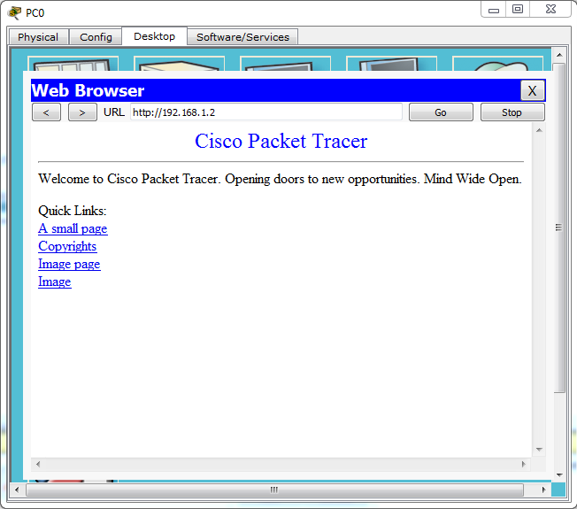

Figure 2

## Task 4, Address Record entry

To access the Web Server via the DNS Server, add an A Record (Address Record) entry in the DNS Server (As shown in figure 3).

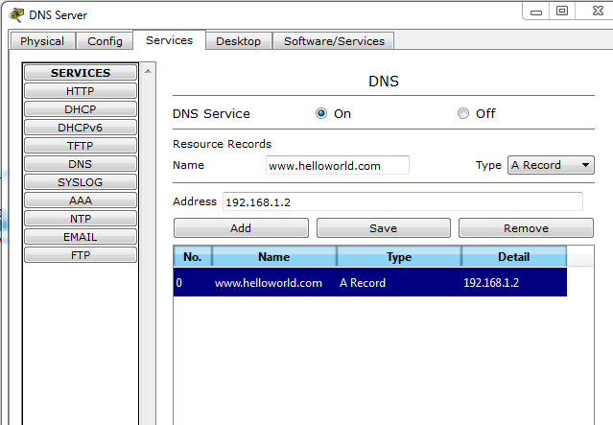

Figure 3

## Task 4, Canonical Name entry

Now enter another entry in DNS Server for helloworld.com as a CNAME (Canonical Name) record (As shown in figure 4).

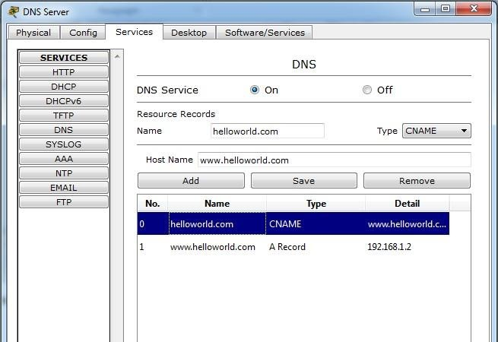

Figure 4

## Task 5, Web Page Searching by Domain

Now open the web browser from the PC again and enter [www.helloworld.com i](http://www.helloworld.com/)n the URL bar (As shown in figure 5).



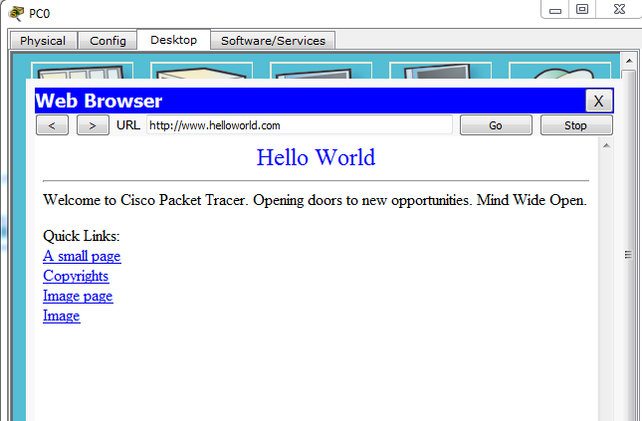

Figure 5